Mini bal du 28 janvier
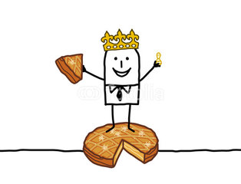
Mama’s pearl’s
Kiss off
Joana
Cowgirls and angels
Wishful thinking
Pavement ends
X.plosive
Baby belle
Foxy girl
Thanks a lot
Bullfrog on a log
Little wagon wheel

